|  |  |  |
| --- | --- | --- |
|  | **ST. FRANCIS INSTITUTE OF TECHNOLOGY**  **Mount Poinsur, Borivali (West), Mumbai-400103**  **Department of Information Technology**  **Information Technology Students’ Association (ITSA)** |  |

***ITSA’ JAVA-SQL CRASH COURSE !!***

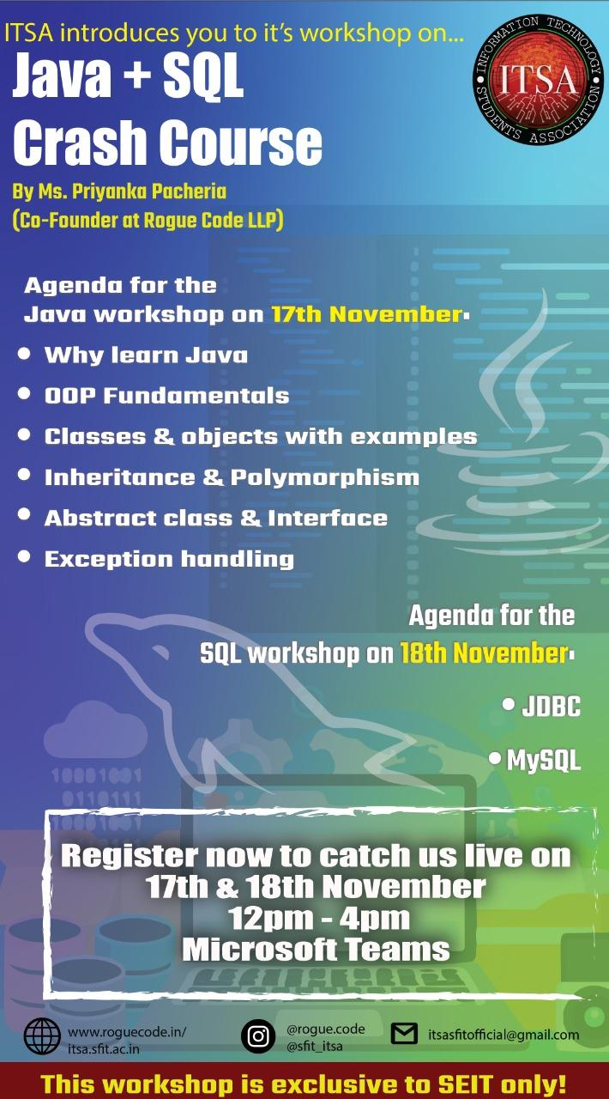

SFIT ITSA keeping up with its legacy is once again here with the JAVA-MySQL workshop/ crash course for the SE students. This course was one of the most needed and useful course for the SE students as the contents of the course were the most useful parts in their mini-projects for the following semester. ITSA has always been looking forward to help the students with its courses and workshop and made sure that the students make the best of the time they invest and the trust they show in us. This crash course was a two day and four parts course; each day had two parts of approximately one and a half hours each.

**Day-1**

**Session -1**

The day one began with our president Mr. Joshua D’souza giving the participants a brief overview of what the crash course was about, the importance of the contents and their uses and then introduced our resource person Ms.PriyankaPacheria. Ms.Priyanka is from Rogue Code academy(Co-Founder) she has a seven year experience in the field and is quite skilled in the database field. The resource person began the session by saying a few things about herself and started with the main agenda of the course.

Then the resource person began with the topics to be covered in the session following with the types of programming languages and the contents of the same. She gave the perfect examples for explaining the same in a brief way. Then coming onto the actual first part of the course the resource person began with JAVA. In the same continuity she covered Features of JAVA , structure of JAVA, OOP concepts in brief and its properties, classes and objects in JAVA. Then began with the hands on session on Eclipse IDE and the codes were provided via a pdf on the website [www.roguecode.in](http://www.roguecode.in) for the students to refer. Then continuing the session the resource person started with Constructors in java, types of Inheritance in javawith the hands on session going on simultaneously. This was the end of session one. Session one (Day-1) was almost one and a half hour long and continued after the break.

**Session 2**

Day-1-Session-2 began with the revision of the previous topics viz. Inheritance in java; And beginning with a new topic ie. Polymorphism, its functions, types, properties and the hands on going on simultaneously. Following this Ms.Priyanka began with the topics: method overloading, method overriding, exception handling and its examples. The types of exceptions and the methods to handle them were then discussed. The session was concluded here with a question answer session between the resource person and the students following with Mr.MukundaGujjar giving a few instructions for the next session.

**Day-2**

**Session 1**

Day 2-Session 1: Started with the new topic of Multi -Threading. For easy understanding Ms.Priyanka started with a simple question of “what is thread?”explained the definition and gave few examples including real life example. Also she asked few questions which were related to previous day’s session. Then she started with Life cycle of Thread and how a thread works was very well explained. Asking a few questions on the same she moved forward to Creation of thread followed by methods in thread class, Methods in Runnable interface with an example which she practically explained in IDE on how multi-threading program will work .She gave another question for students to solve on their own while she was explaining it simultaneously. Students understood it very well and successfully executed it while few queries of students were cleared. With this she moved forward to a new and important topic of Java Database Connectivity(JDBC) starting with Why JDBC? and What is JDBC ? including API. A short video was shared to make it clear. 5 steps of JDBC connection were introduced. Mr .Joshua Dsouza gave instructions to the students to keep ready their server for the last session to go on smoothly and students were asked to clear their doubts regarding the download of servers before the session after the break starts. This where Day2-Session1 ended .

**Session-2**

Day2-Session2:Before starting with the coding part Ms. Priyanka revised the last part she taught before the break about JDBC and 5 steps of connectivity that was introduced. Each and every step was then explained in detail including how, when and where to use them. Miss then started with the coding part where all the students had the follow her and perform each and every steps simultaneously. Many students faced errors while performing which were cleared on the spot. Students were informed to ask the doubts ,queries or errors occurring regarding JDBC connectivity that time itself to avoid future errors and confusion in the coding part. With the completion of 5 steps of JDBC connectivity and performing and executing it very well with the help of the mentor this session came to an end.

Mr.Mukunda Gujjar and Mr.Joshua Dsouza thanked Ms. Priyanka Pacheria for helping ITSA conduct the JAVA-SQL crash course stating that it was very helpful and beneficial for the students to complete their mini-projects and also thanked all the SE’s for their active participation in this webinar.

|  |  |  |
| --- | --- | --- |
| **Mrs. GrinalTuscano** | **Mrs. Shree Jaswal** | **Dr.Joanne Gomes** |
| **(ITSA Coordinator)** | **(ITSA Coordinator)** | **(HOD-IT)** |